Section 3.3
Activity 1
Match each of the pairs of sets with the Venn diagrams provided
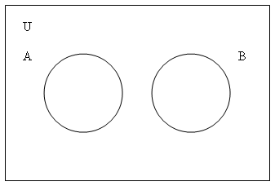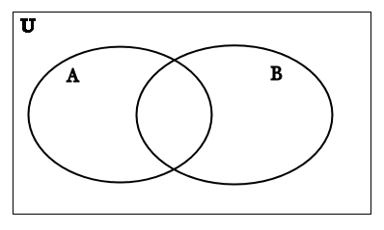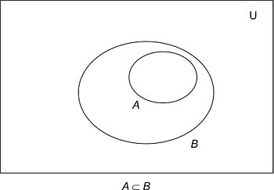

- A = {even numbers} , B = {odd numbers}
- A = {prime numbers} , B = {odd numbers}
- A = {numbers divisible by 4}, B = {even numbers}
- A = {students in this discrete class} , B = {students in data structures}
- A = { students in this discrete class }, B = {students in Networking}
- A = { students in this discrete class }, B = {students at UNI}

Activity 2
For each person in your group, create the pizza of your choice by creating a subset from the following set of toppings.
T = {pepperoni, sausage, Canadian bacon, mushroom, onion, green pepper, jalapeno peppers, anchovies, pineapple, corn}

Activity 3
Assume

- A = { letters in the word ELEPHANT }
- B = { letters in the word SYNCHOPHANT }
- C = {letters in the word FANTASTIC}
- D = {letters in the word STUDENT}
If the universe U is the set of 26 capital letters find:

- A ∪ B
- A ∩ B
- A ∩ C
- D ∪ A
- (A ∩ C ) ∪ (B ∩ D)
- A ∩ (C ∩ D)

