Section 1.4
Part One
Complete the following truth table.
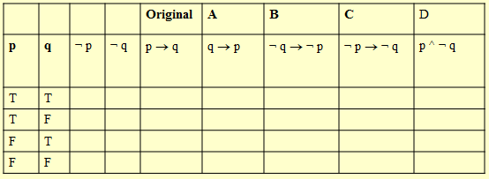

Part Two
Assuming that p → q is the original implication, match columns A-D with their proper vocabulary names.
- Contrapositive
- Converse
- Inverse
- Negation

Part Three
Define these three terms
- Tautology

- Contradiction

- Logically Equivalent

Part Four
Complete the following truth tables to demonstrate the named Laws of Propositional Logic
Associative Laws
 |  |  |  |  |  |  | Proposition #1 | Proposition #2
p | q | r |  |  |  |  | ( p ^ q ) ^ r | p ^ ( q ^ r )
T | T | T
T | T | F
T | F | T
T | F | F
F | T | T
F | T | F
F | F | T
F | F | F

 |  |  |  |  |  |  | Proposition #1 | Proposition #2
p | q | r |  |  |  |  | ( p ∨ q ) ∨ r | p ∨ ( q ∨ r )
T | T | T
T | T | F
T | F | T
T | F | F
F | T | T
F | T | F
F | F | T
F | F | F

Distributive Laws
 |  |  |  |  |  |  | Proposition #1 | Proposition #2
p | q | r |  |  |  |  | p ∨ ( q ^ r ) | (p∨q) ^ (p∨r)
T | T | T
T | T | F
T | F | T
T | F | F
F | T | T
F | T | F
F | F | T
F | F | F

 |  |  |  |  |  |  | Proposition #1 | Proposition #2
p | q | r |  |  |  |  | p ^ ( q ∨ r ) | (p^q) ∨ (p^r)
T | T | T
T | T | F
T | F | T
T | F | F
F | T | T
F | T | F
F | F | T
F | F | F

